NUMERICAL METHODS FOR ENGINEERING ASSIGNMENT.

FET651

Group 6 membres

|  |  |  |
| --- | --- | --- |
| Full Name | Matriculation number | Speciality |
| ABANDA PACILIA COLETTE | FE20P070 | NETWROK |
| NJIKE TCHAPTCHET MAEVA DORCAS | FE20P072 | NETWORK |
| LOUMOU BALATA PATRICK PASCAL | FE20P103 | TELECOM |
| TCHOUASSEU KAMNANG BRICE RUDY | FE20P069 | NETWORK |
| KANGNUO CHENUI NIXON | FE20P076 | NEWTORK |

Calculation

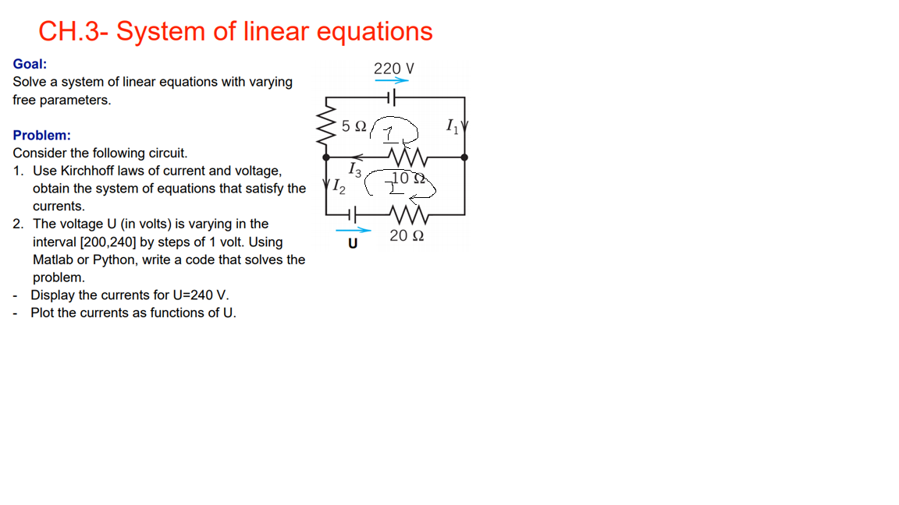

Figure 1: question

Solution

From loop 1, using kirchoff’s law, traversing the circuit in the direction of current, we have;

* I3=I1+I2 1
* -5I1-10I3+220=0

→ +5I1+10I3=220 2

* 10I3+20I2-U=0

→ 10I3+20I2=U 3

This implies that -I1-I2+I3 =0

5I1+0I2+10I3 =0

0I1+20I2+10I3 =0

Expressed in matrix form as; $\left(\begin{matrix}0 \\ 220 \\ u\end{matrix}\right)=\left(\begin{matrix}-1 & -1 & 1 \\ 5 & 0 & 10 \\ 0 & 20 & 10\end{matrix}\right)\left(\begin{matrix}I(1) \\ I(2) \\ I\left(3\right)\end{matrix}\right)$

Python code

import matplotlib

import matplotlib.pylab as plt

import numpy as np

y1= []

y2= []

y3= []

b=[]

# I3 - I1 -I2 = 0 ...........eq1

# 5I1 + 10I3 - 220 = 0.......eq2

# 10I3 + 20I2 -u = 0.........eq3

det= np.linalg.det([[-1 ,-1 ,1],[5, 0 ,10], [0, 20,10]])

for u in range(200, 241):

b.append(u)

for u in range (200,241):

det1=np.linalg.det([[0 ,-1 ,1],[220, 0 ,10], [u, 20,10]])

i1=det1/det

y1.append(i1)

for u in range (200,241):

det2=np.linalg.det([[-1 ,0 ,1],[5, 220,10], [0,u,10]])

i2=det2/det

y2.append(i2)

for u in range (200,241):

det3=np.linalg.det([[-1 ,-1 ,0],[5, 0 ,220], [0, 20,u]])

i3=det3/det

y3.append(i3)

plt.plot(b, y1,label = "i 1")

plt.plot(b, y2,label = "i 2")

plt.plot(b, y3,label = "i 3")

plt.xlabel('U (voltage)')

plt.ylabel('I (Current)')

plt.legend()

plt.show()

Output results

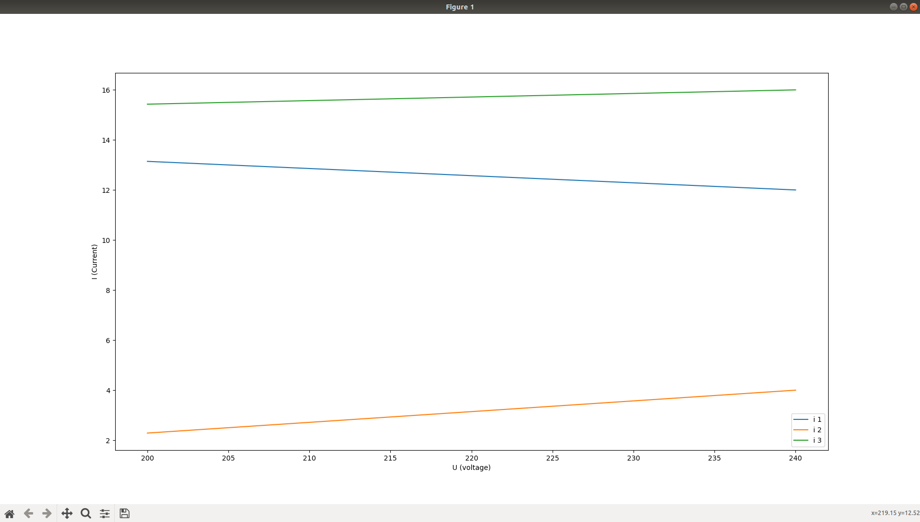

Figure 2: Output result